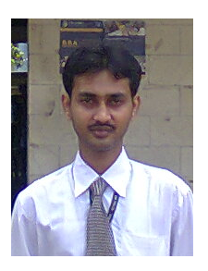

**URRICULUM-VITAE**

**RAJU DAS**

**Academic Qualifications**

|  |  |  |  |  |
| --- | --- | --- | --- | --- |
| ***Degree*** | ***Institute/ University*** | ***Discipline*** | ***Year of Passing*** | ***% Aggregate*** |
| MBA | E.I.I.L.M. | Marketing / Retail | 2013 | 60.3% |
| Post Graduation | Rabindra Bharati University | Environmental Studies | 2009 | 53.2% |
| Graduation | Fakirchand college  University of Calcutta | Bachelor of Arts with Philosophy Honours | 2007 | 45% |
| Higher Secondary | Fatepur Srinath Institution  West Bengal Council of Higher Secondary Education | Arts | 2004 | 49.6% |
| Secondary | Fatepur Srinath Institution  West Bengal Board of Secondary Education | General | 2002 | 53.38% |

**External Project**

* Project Title – “ RETAIL STORE OPERATION PROCEDURE’’ FROM

PANTALOONS GARIAHAT KOLKATA

* Project Duration –Two months

**Interests**

* Playing chess , playing foot ball

**Personal**

* Date of Birth : 22th May 1985
* Guardian’s name : Debprasad Das
* Languages Known :
* English
* Hindi
* Bengali

**Permanent Address**

Address:- village- Kotaldanga, Post- Fatepur, P.S-Falta, Dist-24PGS(South), State- west Bengal, 743513.

Residence No :-(9174) 240153

Mobile: - 9830597930

Email ID: rajudas40091@gmail.com

**Experience**

One year and five months experience in retail, at present working at shopper stop as fashion assistant.